Q1. What data structure(s) could you store this data in? What are the benefits of storing in each of the data structures you can think of?

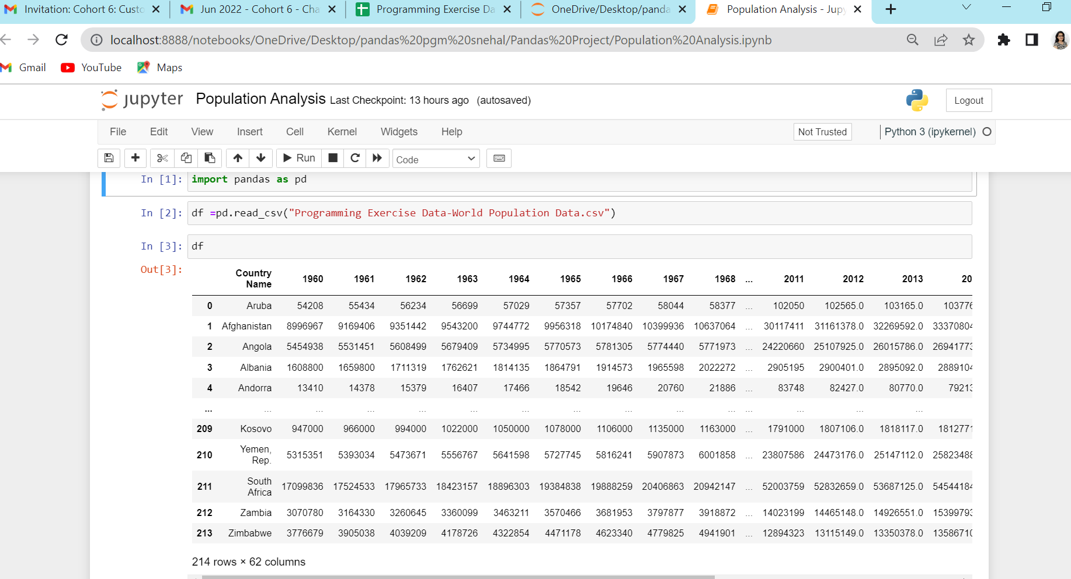

Q2. Write a program/function to find the country/region with the highest and lowest population in a given year. Take the year as input from the user or from the command line.

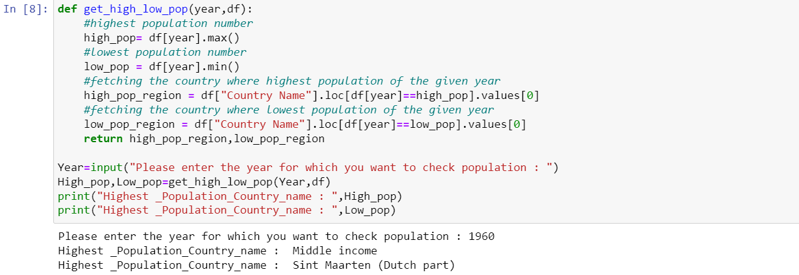

Q3. Write a program/function to find the country/region with the highest and lowest population growth percentage from 1960 to 2020.

Formula: 100 \* (2020 population - 1960 population) / 1960 population

